PV Penetration (MDI)

1. What is the average PV Penetration rate for each substation?
2. What the % in Average PV penetration rate for each substation?
3. Which substations have the highest PV penetration rate?
4. Which feeders and substations have the highest PV Penetration rate?
5. Show the PV penetration rate of the last three years for each substation?
6. Using a tag cloud which substation has the highest PV penetration rate?

Pivot Tables

Statistics

PV Penetration (Calculated – Interconnection Data and AMI)

PV Growth rate

PV (MW/Amps)

PV Susceptibility

Project Charter

* **High-level objectives, constraints, requirements, scope, risks, and assumptions; Assess whether feasible within given constraints**
* **Sponsor**
* **Business Case**
* **Market demand, organizational need, customer request, technological advance, legal requirement, ecological impacts, social need**
* **Statement of work:** Business need, product scope description, strategic plan
* **Measureable project measures and metrics**
* **Operational Procedural Assets** - Applicable process and procedures, templates, lessons learned, knowledge-base (data on previous projects, or data for the project)
* **Enterprise Environmental Factors** – government regulations, trends
* **Authority Levels**

|  |  |
| --- | --- |
| **Step** | page2image7097376  **Description (This is not a comprehensive list; just enough to get you started.)** |
| **Goals**  (Problem / Opportunity) | * Describe the problem or opportunity * Describe or frame the problem/ business problem that needs to be solved (identify any boundaries and constraints) * Describe your hypothesis of the problem. (i.e. assumptions you are making about the problem you are solving and the data you need to solve the problem. * Identify any KPIs, targets and benchmarks (presented in class) that you might use to evaluate whether you are successful or not in solving your problem. |
| **Data / Engineering** | * Provide a description of the data you have access to or have been provided. * Is there any data missing that you need to solve the problem? * Are there any assumptions or inferences that you have to make about the date? * Is it qualitative and or quantitative? * Describe the other characteristics of the data (structured, categorical, etc.) * Provide any other information that describes the source of the data. * Can you identify any issues with the data? (Example: Do you have enough data?) * Do you have to transform the data (delete, add/clean, modify, etc) for your analysis? What did you have to do? |
| page2image3766736  **Analysis**  (Methods or T echniques) | * Describe the type/types of methods/techniques you will use to analyze the data (excel, statistics (averages, etc.), probability, etc.) * Describe any assumptions you are making in choosing your method. * Why do you think the method you are using is the correct method in your judgment? * Is there a potential downside to using the method you have selected. * Document the resulting information from your analysis or calculations? |
| page2image3705792  **Insights** | * Described what youʼve learned from your analysis. * Describe how what you have learned can solve the problem, and any assumptions you have to make in the interpretation of your analysis. * Describe the action/s you will take * Your insights should be actionable. |
| page2image1698496  **Action**  page2image3674592 | * Describe how you will use your insights to solve your problem. What actions will you take? * Will you and how often will you need to adapt your action in the future? |
| **Result** | * Describe the results you expect from your action or actions you have chosen (in terms of targets, KPIS, benchmarks.) * If applicable: Estimate the results, and provide any information to support your assumptions in your estimates. |

|  |  |
| --- | --- |
| **Step** | page2image7097376  **Description (This is not a comprehensive list; just enough to get you started.)** |
| **Goals**  (Problem / Opportunity) | * Describe the problem or opportunity * Describe or frame the problem/ business problem that needs to be solved (identify any boundaries and constraints) * Describe your hypothesis of the problem. (i.e. assumptions you are making about the problem you are solving and the data you need to solve the problem. * Identify any KPIs, targets and benchmarks (presented in class) that you might use to evaluate whether you are successful or not in solving your problem. |
| **Data / Engineering** | * Provide a description of the data you have access to or have been provided. * Is there any data missing that you need to solve the problem? * Are there any assumptions or inferences that you have to make about the date? * Is it qualitative and or quantitative? * Describe the other characteristics of the data (structured, categorical, etc.) * Provide any other information that describes the source of the data. * Can you identify any issues with the data? (Example: Do you have enough data?) * Do you have to transform the data (delete, add/clean, modify, etc) for your analysis? What did you have to do? |
| page2image3766736  **Analysis**  (Methods or Techniques) | * Describe the type/types of methods/techniques you will use to analyze the data (excel, statistics (averages, etc.), probability, etc.) * Describe any assumptions you are making in choosing your method. * Why do you think the method you are using is the correct method in your judgment? * Is there a potential downside to using the method you have selected. * Document the resulting information from your analysis or calculations? |
| page2image3705792  **Insights** | * Described what youʼve learned from your analysis. * Describe how what you have learned can solve the problem, and any   assumptions you have to make in the interpretation of your analysis.   * Describe the action/s you will take * Your insights should be actionable. |
| page2image1698496  **Action**  page2image3674592 | * Describe how you will use your insights to solve your problem. What actions will you take? * Will you and how often will you need to adapt your action in the future? |
| **Result** | * Describe the results you expect from your action or actions you have chosen (in terms of targets, KPIS, benchmarks.) * If applicable: Estimate the results, and provide any information to support your assumptions in your estimates. |

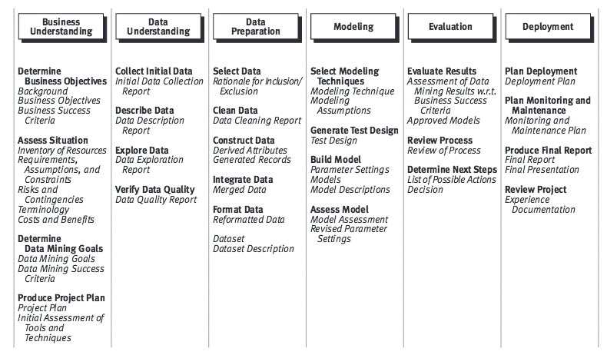

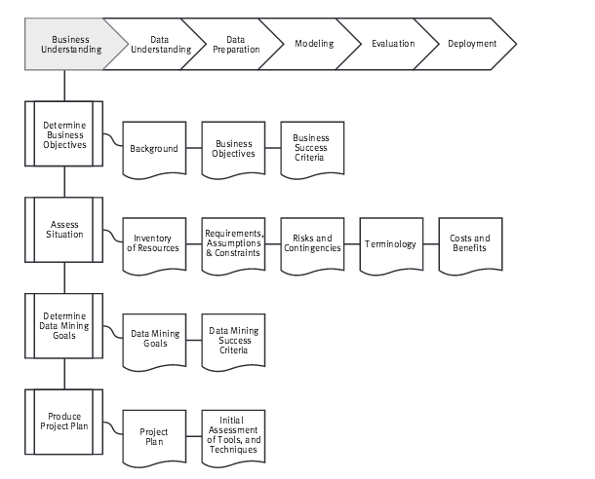

Framing the problem

AJames/Calstatela

Adapted from EMC, CRISP-DM, and MIT/Sloan article, “The Secret to Managing Analytics Projects”

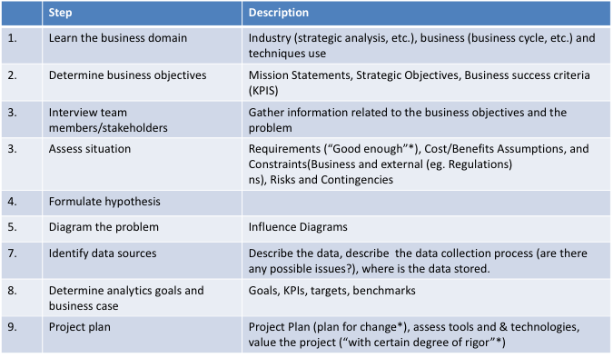

Example

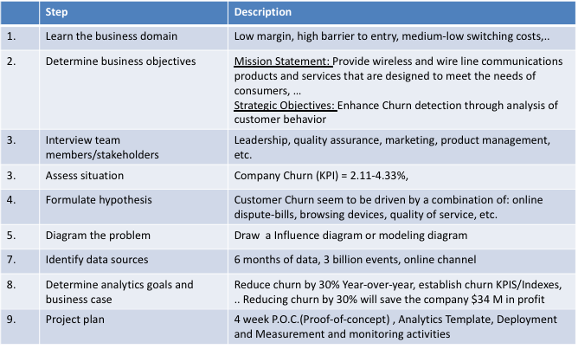

Business Understanding



Modeling Process

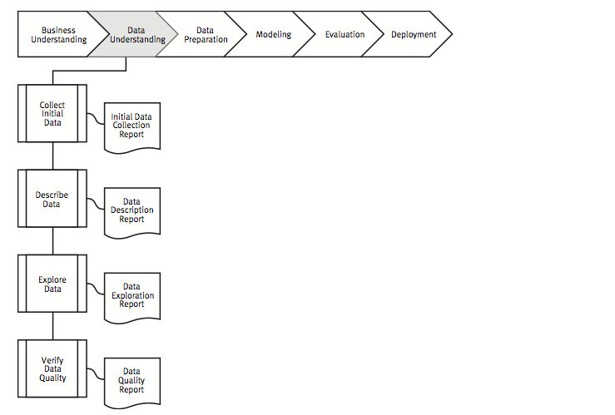

Data Preparation



=====

Presentation Format: EMCDSA